Lab 7

Training a Cancer Diagnosis Agent

with DT

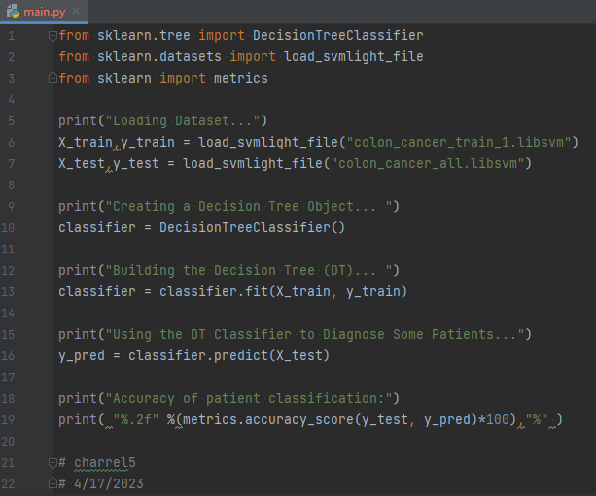

1. What does it print?
   1. Loading Dataset...
   2. Creating a Decision Tree Object...
   3. Building the Decision Tree (DT)...
   4. Using the DT Classifier to Diagnose Some Patients...
   5. Accuracy of patient classification:
   6. 88.71 %
   7. 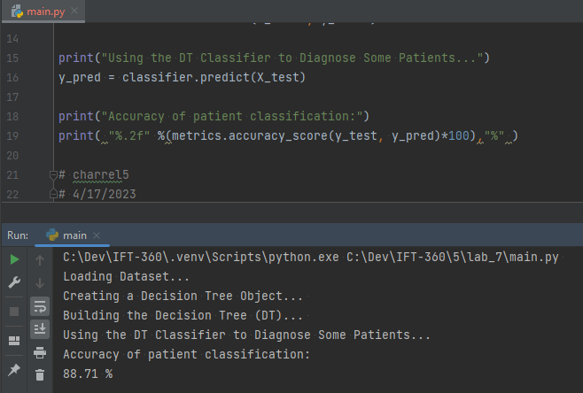
2. What is the obtained classification accuracy?
   1. 88.71 %
   2. 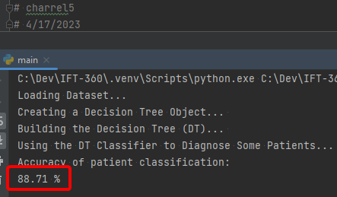
3. Do you think this accuracy is good or bad? Justify.
   1. I think this accuracy is a good start, but I think it is **bad** when considering the impact it would have on patients. 11.29% of patients will be misclassified. I do not know how expensive (in terms of time, cost, and patient comfort) it is to collect all of these data points. I presume it is not very expensive - perhaps some physical measurements, observations, and blood work. If my presumption is correct, then I think this can serve as a valuable diagnostic aid. It’s not good enough to use as a singular diagnostic tool however.